M2: Hands-On Lab Walkthrough

Lab 2 Exercise: Refine Your Prototype with Advanced Prompting Techniques

✍️ Optional: You can use the AI Prototyping: Prompting Template to help you complete the lab, but it is not mandatory.
TASK: Using Lovable, your group will evolve one member’s generic "V1" baseline created in the first lab with a core prompting technique into a high-fidelity prototype through two targeted iterations. You will first analyze the baseline using the FUDI framework, then refine it using Strategic and Cutting-Edge prompting techniques. Your goal is to experience how specific prompt structures directly elevate prototype fidelity.
Reminder: Fitness Companion App
You’re a PM building an AI-powered fitness app that provides personalized fitness recommendations. For this exercise, you are focusing exclusively on the Goal Setting Screen—the initial UI where users select their primary fitness objective (e.g., Weight Loss vs. Muscle Gain).

Step 1: Select a Prototype and Analyze Using FUDI
- Spend a few minutes reviewing the individual "V1" prototypes each member generated in the first lab and select one to serve as the group's "master baseline."
- Analyze this V1 using the FUDI Framework to identify specific gaps and write down your specific diagnosis notes for each category (F, U, D, I):

Functionality: Is core logic missing?  (e.g., "Does it actually filter?" | ✍️ Write your notes here
User Flow: Is the path clear?  (e.g., "Where does the 'Create Workout' button go?") | ✍️ Write your notes here
Design: Is it generic?  (e.g., "Does it look like a wireframe or a brand?") | ✍️ Write your notes here
Interaction: Is it static?  (e.g., "Do buttons have states?") | ✍️ Write your notes here
- Add a screenshot of the current V1 state and paste it as a comparison for your “before.”
📸 Add your screenshot here

Step 2: Refine Your Logic with Strategic Prompt Techniques
- Have the person whose V1 you chose launch Lovable in their browser and share their screen to begin building your group’s prototype.
- Focus on the logic (user flow or functionality gaps you identified) and use a strategic prompt, such as prompt chaining, RAG, or self-consistency, to address the gaps. Paste one of the following prompts into the chat.
💡Note: You’re welcome to try and write a prompt yourself, rather than copy-pasting ours. They’re here to help you if you’re feeling stuck!
OPTION A: Prompt Chaining (Best for Complex Logic) Use this if your V1 was missing core data or functionality.
Prompt 1 (The Logic): Paste this first to define the structure.
"I need to refine the logic for the Goal Setting screen. First, just define the data structure. Create a JSON schema that tracks:
- primaryGoal (Options: Weight Loss, Muscle Gain, Endurance)
- workoutFrequency (Slider: 1-7 days)
- experienceLevel (Beginner, Intermediate, Pro) Do not build the UI yet. Just output the schema and validation logic."
Prompt 2 (The Build): Once the AI replies with the schema, paste this to generate the screen.
"Great. Now, use that exact schema to build the React component.
Use Radio Cards for the primaryGoal.
Use a range slider for workoutFrequency.
Ensure the 'Next' button is disabled until the schema validation passes."
* ⚠️ Note on Credits: As mentioned in class, Prompt Chaining will use more credits, as you need to wait for the first output before sending a second prompt. If you choose this option and you have a free account, you will likely run out of credits before you can get to cutting-edge techniques.
The Trade-off: You spend more credits to gain stability. By stopping the AI halfway, you ensure the "Logic" is perfect before it wastes tokens generating the "UI."
OPTION B: Self-Consistency (Best for User Flow) Use this if your V1 flow felt clunky or confusing.
B: "I need to improve the user flow for selecting a fitness goal. Generate 2 different flow concepts:
'Speed Flow': A single screen with quick-select options.
'Guided Flow': A multi-step wizard (Goal -> Frequency -> Confirmation). Evaluate both for a mobile user and implement the one that minimizes friction. Justify your choice."
*⚠️ Note on Output: You are unlikely to see Lovable actually generate two different UI versions side-by-side. Instead, it will perform the reasoning internally and only show you the one it decides is best, along with an explanation of why it chose it.
- Compare the results with your V1, take a screenshot of the result, and add any key differences.
📸 Add your screenshot here
✍️ Write your notes here

Step 3: Push AI To Self-Improve With Cutting-Edge Prompts
- Return to your V2 strategic prompt prototype from step 2 and repeat the process using a cutting-edge prompting technique. This will force the AI to act as its own QA lead or Senior Designer.

🚀Pro Tip (Save Credits!):
You don't need to spend Lovable credits to generate the prompt.
- Copy your current V2 prompt, paste it into ChatGPT, Gemini, Claude (etc.) for free with the example prompt below to get your “improved” prompt.
- Then, paste the results back into Lovable to build.
- Alternatively, you can try toggling on the chat mode in Lovable, which will work like an AI tool without generating any code or UI, saving you credits.
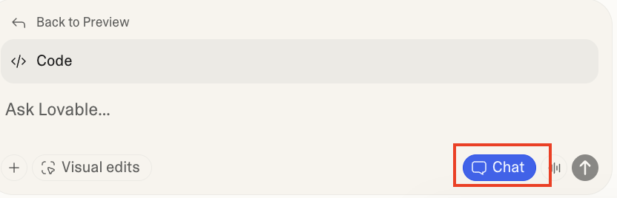
Paste one of the following prompts:
💡Note: You’re welcome to try and write a prompt yourself, rather than copy-pasting ours. They’re here to help you if you’re feeling stuck!
OPTION A: Reflection (The "QA" Approach) Use this if the V2 works but feels "buggy" or unpolished.
"Review the current Goal Setting screen code. Critique it against these four product pillars:
Functionality: Does the logic work?
User Flow: Is the path clear?
Design: Is the layout polished?
Interaction: Does it give feedback?
Focus specifically on Design and Interaction. Identify 3 gaps (e.g., missing hover states, bad spacing) and regenerate the code to fix them."
📝 Note: Lovable automatically reads your current project files. You do not need to copy and paste the code blocks into the chat; simply referencing "the current Goal Setting screen" is sufficient.
However, if you plan to try this in another tool outside of Lovable, you will also need to paste the code as a reference.
OPTION B: Meta-Prompting (The "Expert" Approach) Use this if the V2 feels generic and needs a total upgrade.
Step 1: The Architect (External AI / Chat Mode) Paste your previous V2 prompt into ChatGPT, Claude, or Lovable Chat Mode with this instruction:
"Act as a Senior Product Designer. Critique my previous prompt for the goal-setting screen: '[Insert V2 Prompt]'.
Rewrite this prompt to be more specific. Explicitly define the Design constraints (e.g., 'Use a card-based layout with shadow-sm') and Interaction details (e.g., 'Add a pulse animation on selection').
Output ONLY the refined prompt text."
Step 2: The Builder (Lovable Agent Mode) Copy the new, refined prompt that the AI gave you. Paste that into the main Lovable builder to generate your V3.
- Compare the results against the strategic prompt output, take a screenshot of the output, and add any key differences.
📸 Add your screenshot here
✍️ Write your notes here

